**[TITLE IN CAPITAL LETTERS]**

Authors Name1*,* Authors Name*2

*1line 1 (of Affiliation): dept. name of organization*

*line 2: Name of organization, acronyms acceptable*

*line 3: City, Country*

*line 4: e-mail: name@xyz.com*

*2line 1 (of Affiliation): dept. name of organization*

*line 2: Name of organization, acronyms acceptable*

*line 3: City, Country*

*line 4: *Corresponding e-mail: name@xyz.co*

**ABSTRACT**

The abstract should be strictly between 150 - 300 words.

**Keywords:** word1; word2; word3 (3 to 5 words or phrases, Take 2 or 3 from title.)

**1. Introduction**

Provide the study background in simple words. Provide references to all the facts presented in this section in APA style.

**2. Literature Reviews**

A literature review can be written to meet your research needs. This section can also be combined with the introduction section. The author can discuss the research gap that this study is going to or is willing to fill in this section. Provide an APA-style in-text citation.

**3. Methodology**

For the quantitative study, include the population and sample [criteria of population selection and method of sampling materials/tests with descriptions, variables, nature of data, data collection techniques, and data analysis methods. Discuss software and hardware used during the study with their brand names. This section should be easy enough for readers to repeat the study under similar conditions.

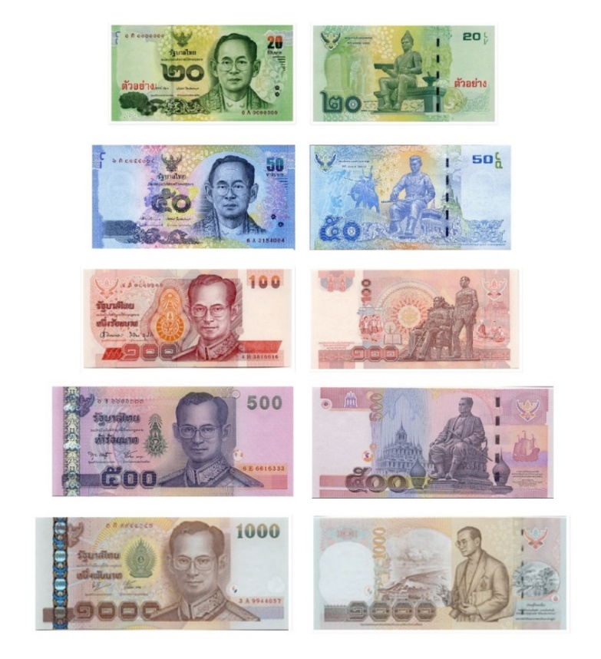

**Figure 1** Thai banknotes (Source: [1])

Table 1 Fonts

|  |  |  |  |
| --- | --- | --- | --- |
| Header | Header | Header | Header |
| Content | Content | Content | Content |
| Content | Content | Content | Content |
| Content | Content | Content | Content |

**4. Results**

Presents the data, the facts – what you found, calculated, discovered, observed.

**5. Conclusion and Recommendation**

Provide logical and scientific analysis of the study findings. Present evidence to support your analysis by citing the work of earlier researchers or existing theories. [How do your results agree to disagree with previous studies, and why? The conclusion should be written in very clear words. It should explain how the objectives of the study are accomplished.

**Acknowledgment**

The author should present a list of acknowledgments at the end. Any financial or nonfinancial support for the study should be acknowledged.

**6. References**

**Compiling References for Research Articles Using APA Style**

To honor individuals, institutions, or organizations that own specific ideas, concepts, or information, the author(s) must cite your articles properly. Citations in research articles must follow the **APA Style (American Psychological Association Style)**. In-text citations should use the author-year format, such as (Author, Year), e.g., (Sawat Pathomkulniti, 2017)/(Sawat Pathomkulniti & colleagues, 2017).

### In-text Citations Example:

* **At the beginning of the sentence,** Sawat Pathomkulniti (2017) stated... Pinyo Prommuang and colleagues (2016) stated...
* **At the end of the sentence:** (Supawadee Sangwan, 2020) (Eric N. & Chuck L., 2008)

### End-of-Article References:

Start with Thai-language references, followed by English-language references. Each article must include at least five references.

### Examples of Different Types of References:

#### 1. ****Books****

* **Format:**  
  Author. (Year). Title. Place of Publication: Publisher.
* **Examples:**

Prapapan Rukliang. (2017). **Principles and Practices of Educational Management.** Bangkok: Chulalongkorn University.

Tisna Khemmanee. (2008). The Art of Teaching (5th ed.). Bangkok: Chulalongkorn University.

Good, C. V. (1973). **Dictionary of Education**. New York: McGraw-Hill.

#### 2. ****Journals****

* **Format:**  
  Author. (Year). Title of Article. **Journal Name**, Volume (Issue), Page Numbers.
* **Examples:**

Kritthapak Mairiang. (2020). Innovative Business Management for SMEs. **Journal of Social Sciences and Buddhist Anthropology,** 5(2), 255–268.

Fullan, M. (2006). The Future of Educational Change: System Thinkers in Action. **Journal of Educational Change**, 7(3), 113–122.

#### 3. ****Conference Proceedings****

* **Format:**  
  Author. (Year). Title of the Conference Paper. In **Conference Name** (Page Numbers). Place: Organizer.
* **Examples:**

Nipon Kaewtai, Sirikarn Rotim, Sumitta Bunla, & Kanoknan Lhasongmuang. (2017). Detecting Prohibited Substances in Herbal-Containing Cosmetics among College Students. In **1st National Conference on Health Sciences**, December 7–8, 2017 (1–7). Chiang Rai: Mae Fah Luang University.

Wewerka, J., Dax, S., & Reichert, M. (2020). A User Acceptance Model for Robotic Process Automation. In **Proceedings of the IEEE 24th International Enterprise Distributed Object Computing Conference (EDOC)** (97–106). Eindhoven: Netherlands.

#### 4. ****Theses/Dissertations****

* **Format:**  
  Author. (Year). Title of Thesis. Master's Thesis, Faculty, University.
* **Example:**

Chaiwat Penghirun. (2019). **Factors Influencing Hotel Selection for Boutique Hotels in Chiang Mai.** Master’s Thesis, Faculty of Business Administration, Ramkhamhaeng University.

#### 5. ****Newspapers****

* **Format:**  
  Author. (Date Month Year). Title of Article. **Newspaper Name**, Page Numbers.
* **Example:**

Thawat Wirattipong. (14 March 2006). Revolutionizing New Researchers. **Matichon**, 8.

#### 6. ****Electronic Documents****

* **Format:**  
  Author. (Year). Title. Retrieved on Date from URL.
* **Example:**

Brian, F. (2009). The 4 P’s Are Out, the 4 E’s Are In. Retrieved on April 20, 2023, from [**https://www.linkedin.com/pulse/20141204091656-87374558-why-the-4e-sof-marketing-are-replacing-the-old-4p-s**](https://www.linkedin.com/pulse/20141204091656-87374558-why-the-4e-sof-marketing-are-replacing-the-old-4p-s)**.**

#### 7. ****Electronic Journals****

* **Format:**  
  Author. (Year). Title of Article. **Journal Name**, Volume(Issue), Page Numbers. Retrieved on Date from URL.
* **Example:**

Valentino, A. L., Schillingsburg, M. A., Conine, D. E., & Powell, N. M. (2012). Decreasing Echolalia in Echoic Training Using the Cue-Pause-Point Procedure. **Journal of Behavioral Education**, 21(4), 315–328. Retrieved on July 17, 2022, from <http://doi.org/10.1007/s10864-012-9155-z>.

#### 8. ****Interviews****

* **Format:**  
  Interviewee. (Year). Title of Interview, Interviewer.
* **Example:**

Phra Kru Sarathinan. (2021). **Sustainable Marketing Innovation and Digital Marketing Training for Eastern Provinces: Case Study of Chonburi, Rayong, Chantaburi, and Trat**, Interview.

#### 9. ****Government Gazettes****

* **Format:**  
  Name of Law. (Year, Date Month). **Government Gazette**, Volume, Issue, Page Numbers.
* **Example:**

Constitution of the Kingdom of Thailand B.E. 2560. (2017, April 6). **Government Gazette**, 134, 40G, 1–90.

### Notes:

1. Thai authors should include their full name without titles, except for royal titles, which should follow their name, separated by a comma. Monastic titles remain unchanged.
2. For two authors, Thai citations use "and" between names, while English uses "&."
3. For more information on APA Style, consult official resources related to academic writing.